PROMOTING INTEGRATED LANDSCAPE MANAGEMENT APPROACH FOR CONSERVATION OF THE MOUNT ELGON ECOSYSTEM IN EASTERN UGANDA PROJECT

Background

The Government of Uganda has identified and prioritized equitable access to productive land, sustainable natural resources management and integrated landscape planning and management as critical development pathways for meeting economic growth, poverty reduction and industrialization. One of the country’s critical landscapes faced with vast land management challenges is the Mt. Elgon landscape. This mountain landscape is a food basket supporting a population of approximately four million people with productive yet vulnerable resources. The Mt Elgon landscape is a source of critical goods and services that support biodiversity, watersheds, local community livelihoods and socio-economic development Because of the critical nature of the Mt Elgon landscape, a project was conceived to address the vast land management challenges facing the landscape.

Promoting Integrated Landscape management approach for conservation of the Mount Elgon ecosystem in Eastern Uganda project is a Government of Uganda project funded by the Global Environment Facility (GEF) through the UN Environment. The project is being implemented by the National Environment Management Authority (NEMA) in collaboration with relevant partners at national and district levels. It aims to enhance food security and conserve the ecosystems that provide critical goods and services for rural livelihoods in the Mt. Elgon landscape.

Project goal, objective, Components, Outcomes and Outputs

The project goal is to enhance conservation of ecosystems that provide critical goods and services for rural livelihoods and food security in the Mt. Elgon landscape.
The project objective is to transition the Mt. Elgon landscape to a sustainable, biodiverse, climate-resilient, integrated landscape with efficient coffee and staple crops (maize, beans, banana and Irish potato) value chains.

Project Components, Outcomes and Outputs

The project has four components with different Outcomes and outputs as detailed below:
Component 1: Integrated Mt. Elgon Landscape Management System and institutional frameworks and improved governance. This component aims to: 1) reconcile forest and land degradation, climate change impacts and unsustainable farming practices that increase biodiversity loss and climate change impacts with biodiversity conservation, and 2) strengthen the landscape natural resources governance framework. This is being undertaken through adopting Integrated landscape approaches at Landscape and National Level (Outcome 1.1) and strengthening institutional and governance systems for implementation of the integrated Landscape plan (Outcome 1.2).

Integrated landscape approaches in the Mt. Elgon landscape are planned because of land resource degradation driven by inappropriate land use and climate change related effects. To guide the adoption and implementation of integrated landscape management approaches, the project will update information on land use and vulnerability to climate change impacts in the Mt. Elgon landscape to inform the land use participatory planning process in all the nine District Local Governments (DLGs) in the Mt Elgon region (Output 1.1.1); develop a Sustainable Integrated Land Management plan through participatory processes (Output 1.1.2); mainstream Integrated Landscape Management (ILM) approaches and biodiversity conservation into district local government and sectoral development plans and budgets (Output 1.1.3); and identify and address barriers hindering gender participation in ILM approaches (Output 1.1.4).

To address institutional, policy and legal framework inadequacies reflected in continued challenges of environmental degradation, the project will strengthen the capacity of extension workers and key local government leaders to manage natural resources within Mt. Elgon landscape (Output 1.2.1); strengthen existing structures (Mt. Elgon Stakeholder Forum, Catchment Management Committees) to promote inter-institution coordination and collective action (Output 1.2.2); and strengthen governance, enforcement of laws and compliance monitoring at landscape level to improve the regulatory environment (Output 1.2.3).

Component 2: Sustainable coffee and staple crops production practices and responsible value chains. The diffusion of ILM and SLM into the priority sectors of Agriculture, Forestry and Land will be done by influencing policy through evidence-based action that shows increased adoption of sustainable coffee and staple crops production practices in the Mt. Elgon landscape (Outcome 2.1) and increased share of coffee and staple crops production from Mt. Elgon region being marketed through responsible value chains (Outcome 2.2). Outcome 2.1 will be achieved by: (i) promoting highland specific climate-smart agriculture and SLM practices, including on-farm diversification (Output 2.1.1); (ii) creating incentives (revolving funds and credit schemes) in conjunction with the private sector for sustainable production of targeted crops and their marketing (Output 2.1.2); and (iii) building the capacity of farmers, extension workers and other actors to apply sustainable coffee standards along the coffee value chain (Output 2.1.3). And, Outcome 2.2 will be achieved by: (i) building the capacity of the smallholder farmers (women and men) to participate in the coffee and food crop value chains (Output 2.2.1), (ii) developing and strengthening coffee and food crop value chains and linking them to markets (Output 2.2.2), and (iv) developing and disseminating protocols for sustainable coffee production so as to influence policy (Output 2.2.3).

Component 3: Natural habitat restoration. Under this component, degraded forests, fragile lands and unstable slopes will be restored to improve biodiversity conservation, ecosystem services and carbon stocks. This will be done to improve the condition of habitats to ensure biodiversity conservation, preservation of ecosystem services and maintenance of carbon stocks (Outcome 3.1). Improving habitat conditions will be achieved by undertaking sustainable restoration of 20,000 ha of degraded forests and wetlands in the nine project districts (Output 3.1.1); restoring 35,000 hectares of degraded farmland, fragile lands, unstable slopes and hilltops in the Mt Elgon landscape (Output 3.1.2); and increasing stakeholder awareness and understanding of the benefits of restoring degraded forests, fragile lands and unstable slopes to communities, local economies and nature (Output 3.1.3).

Component 4: Knowledge management (sharing, learning and scaling up). Improved knowledge on Integrated Landscape Management approaches at local, landscape, national, regional and global levels is expected to be realized and best practices and lessons learned documented, shared and adopted. To that end, the project will facilitate and enhance knowledge acquisition and experience sharing at local, landscape, national, regional and global levels through better access to information, knowledge, learning and networking. The aim is to enable Sector agencies and relevant institutions apply ILM approaches in their planning and policies (Outcome 4.1). This will be achieved by implementing several gender-responsive activities, namely; (i) developing and operationalizing an interactive M&E system to track implementation of ILM in Mt. Elgon landscape (Output 4.1.1); (ii) documenting best practices and lessons learned and training key project and GoU staff in that respect for sustainability purposes (Output 4.1.2); (iii) sharing of best practices and lessons learned at landscape, national and regional levels through multi-stakeholder platforms (Output 4.1.3); and, (iv) sharing of best practices and lessons learned at regional and global Food Systems, Land Use and Restoration (FOLUR) partners and Country Projects (CPs) meetings and conferences (Output 4.1.4).

Project sites

The project is being implemented in a total of 38 sub-counties in the districts of Bududa, Bukwo, Bulambuli, Kapchorwa, Kween, Manafwa, Mbale, Namisindwa and Sironko (see the map below).

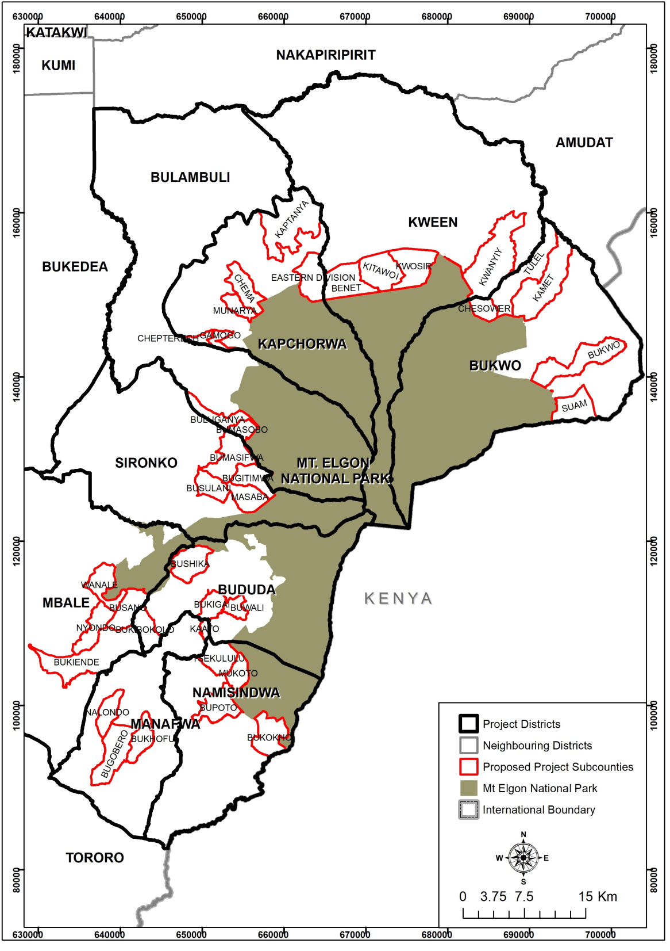

PROJECT COST AND DURATION

- GEF support – USD 9,433,027
- Cash co-financing USD 49,128,890
- In-kind co-financing USD 32,885,110
- Total project cost – USD 91,447,027
- Project Duration – 60 months.

